Web-Based Document Automation Management System

*Felicisimo, Melvin G.*

*Aster, Kyle Chadwick V.*

*Rosel, Bryan Russel I.*

**Data Mapping**

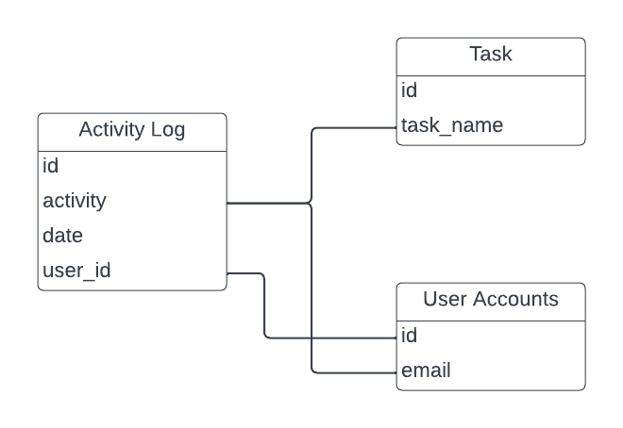

*Activity Log Process*

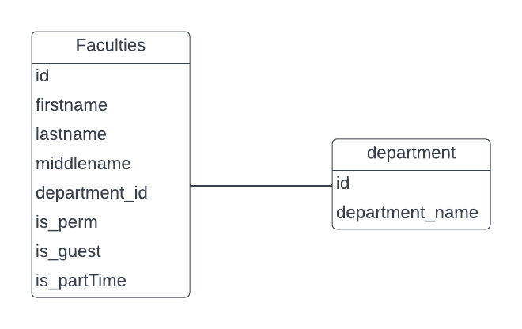

*Faculties Process*

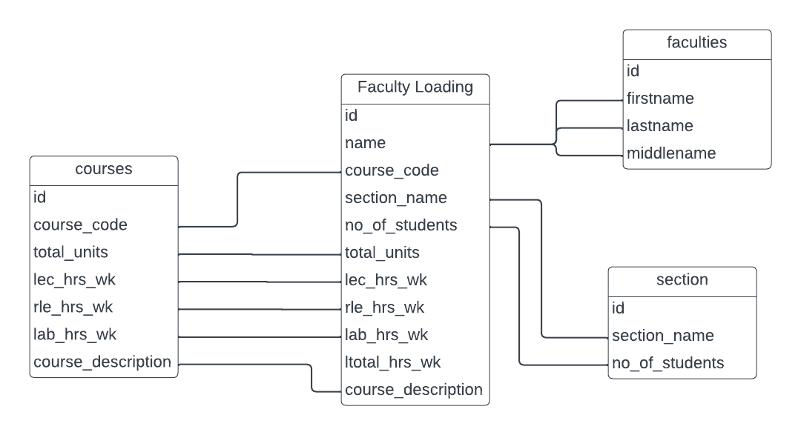

*Faculty Loading Process*

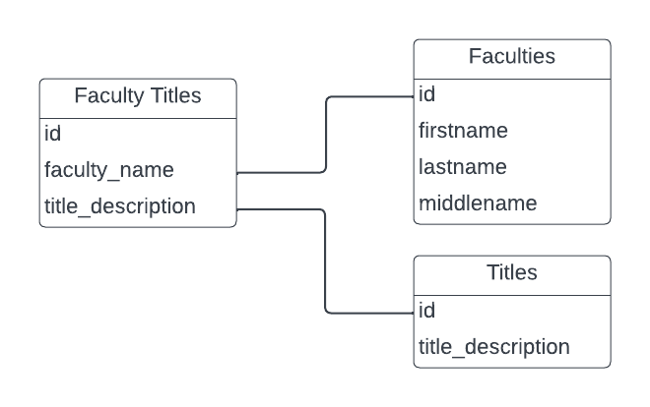

*Faculty Titles Process*

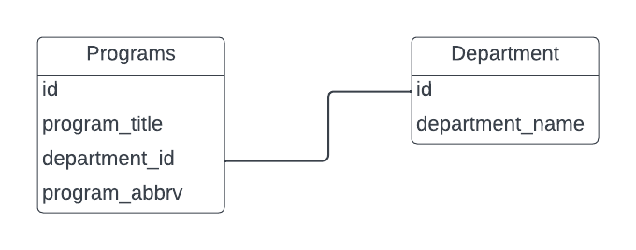

*Programs Process*

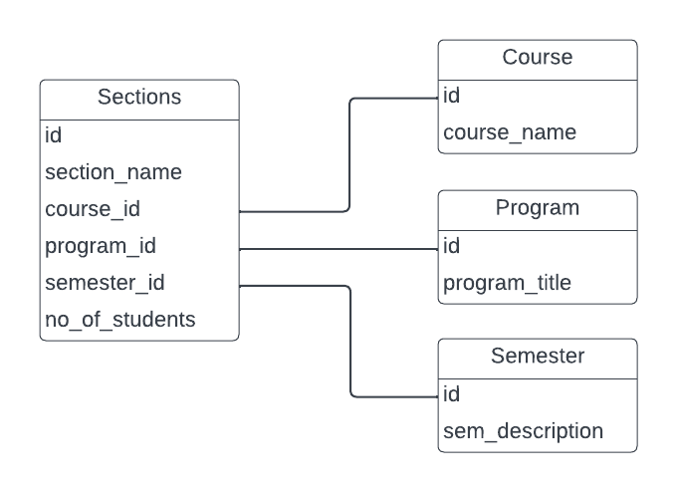

*Sections Process*

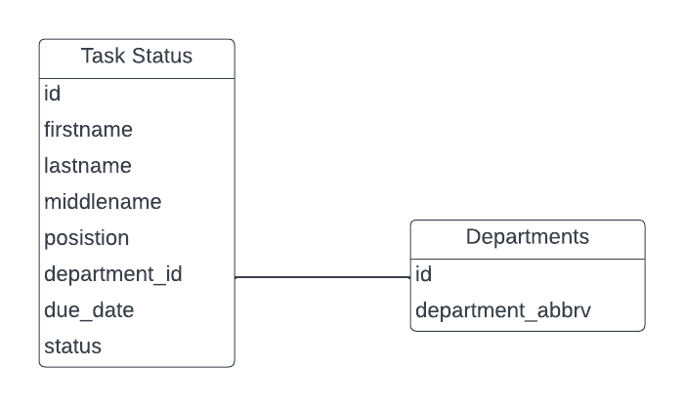

*Task Status Process*

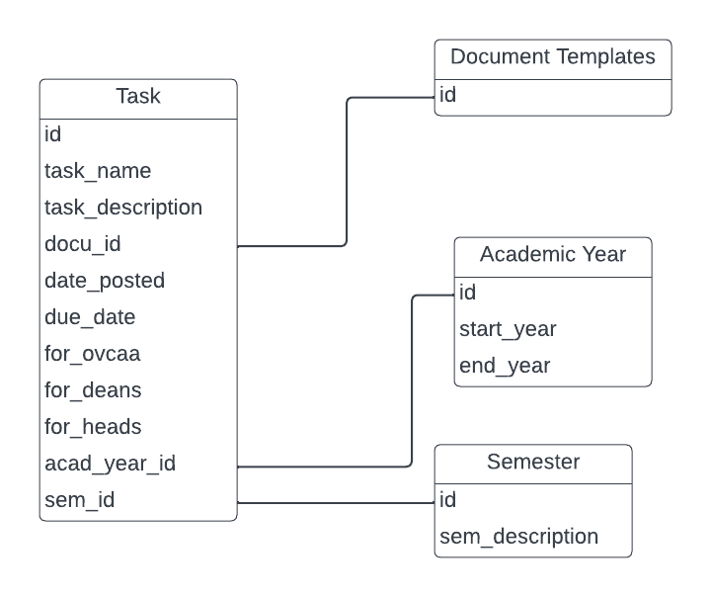

*Task Process*

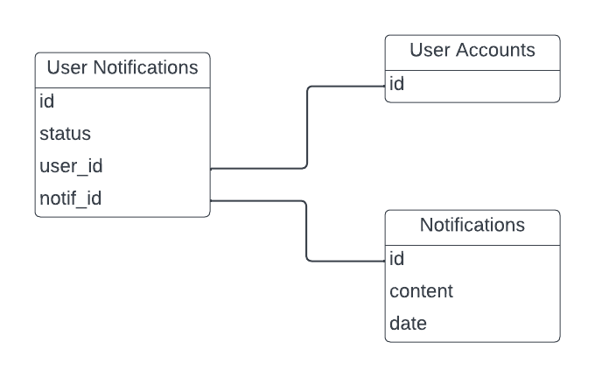

*User Notifications Process*